PRESENTING CLINICAL SIGNS
History: Coughing without improvement on Hydrocodone. Wakes up throughout the night coughing. Did present coughing episode a few times during scan, had to give a few breaks. Grade 3/6 heart murmur and history of tracheal collapse.
-Radiographs: Mild left atrial enlargement suspected and suspicion of valve disease.

ECHOCARDIOGRAM FINDINGS
2D, m-mode, color flow and doppler imaging is available. Mild thickening of the mitral valve leaflets with no prolapse into the left atrial lumen. Trace mitral regurgitation with no left atrial dilation. Normal LV diameter with adequate myocardial function. The tricuspid valve appears normal with no obvious tricuspid regurgitation. Normal right atrial and ventricular diameter and morphology indicating no overt evidence of pulmonary arterial hypertension. The pulmonic and aortic valves are normal in morphology and mobility. Normal pulmonic and aortic outflow velocities with laminar flow. No obvious aortic or pulmonic insufficiency. No pericardial or pleural effusion noted. No obvious cardiac masses.

CARDIAC CHART
CANINE  CARDIAC  PARAMETERS | MR  VMAX  (m/s) | TR  VMAX  (m/s) | LA/AO  (Boon method) | LA/AO  (Heart Base; Swe) | FS  (%) | EF  (%) | EPSS  (cm)
NORMAL PARAMETER | 4.5-5.5 | <2.7 | 1.3 | <1.6 | 28-40 | 40-100 | <0.6
PATIENT | NM | NA | 1.3 | 1.2 | 47 | 80 | 0.33
CANINE  CARDIAC  PARAMETERS | HR  (BPM) | AV  VMAX  (m/s) | PV  MAX  (m/s) | BODY WEIGHT  (kg) | LA  2D short axis  Base view  (cm) | LVIDd  Avg; 2D and m-mode short axis  (cm) | LVIDs  Avg; 2D and m-mode short axis  (cm)
NORMAL PARAMETER | 50-100 | 0.7-1.7 | 0.7-1.6 | BELOW | BELOW | BELOW | BELOW
PATIENT | NM | 1.3 | 1.0 | 8.0 | 1.8 | 2.1 | 1.1
*Normal chamber parameters expressed as a mean value (SD) |  |  |  | 3 | 1.27 (5.3) | 2.46 (2.46) | 1.36 (5.5)
BODY WEIGHT DEPENDENT PARAMETERS  *Note: All measurements based upon multi-modal images and methods. An average value is reported.  Adapted from June Boon, Veterinary Echocardiography, 1998  Rishniw M and Hollis NE, J Vet Intern Med 2000; 14:429-435  Hansson et al, Vet Rad and Ultrasound 2002  Bonagura et al. Echocardiography: principles of interpretation, Vet Clin North Am 15:1177, 1995 |  |  |  | 5 | 1.40 (4.5) | 2.74 (5.2) | 1.60 (4.7)  2.06
 |  |  |  | 10 | 1.50 (3.8) | 3.27 (3.5) | 2.06 (3.1)
 |  |  |  | 15 | 1.83 (2.0) | 3.71 (2.4) | 2.43 (2.1)
 |  |  |  | 20 | 2.02 (1.9) | 4.14 (2.2) | 2.80 (2.0)  3
 |  |  |  | 25 | 2.18 (2.4) | 4.48 (2.9) | 3.10 (2.5)
 |  |  |  | 30 | 2.33 (3.3) | 4.83 (3.9) | 3.39 (3.4)  3.69 (
 |  |  |  | 35 | 2.48 (4.3) | 5.17 (5.0) | 3.69 (4.5)
 |  |  |  | 40 | 2.62 (5.2) | 5.48 (6.1) | 3.96 (5.4)
 |  |  |  | 50 | 2.88 (7.1) | 6.07 (8.3) | 4.46 (7.4)

INTERPRETATION OF THE FINDINGS & FURTHER RECOMMENDATIONS
Overtly normal cardiac dimensions and function, with no obvious dysfunction or dilation of the left heart. A small mitral leak is noted, which is unlikely to be heard on exam. This may reflect early valve disease or may be physiologic in origin. No other significant valvular leaks are visualized, and no evidence of pulmonary hypertension.

No cardiac medications are indicated at this time as the cough appears non-cardiac in origin. Continued work up for infectious/inflammatory respiratory causes is recommended. Options include Baytril or similar antibiotic, anti-inflammatory prednisone, more aggressive hydrocodone, etc. If refractory, may consider TTW/BAL for further information.

Monitor for development of a heart murmur, cough, labored breathing, exercise intolerance or collapse episodes.

Chronic respiratory issues can lead to pulmonary hypertension if poorly controlled and a recheck echocardiogram is recommended should any exertional syncope/dyspnea occur, or a murmur be noted in the future.

IMAGES
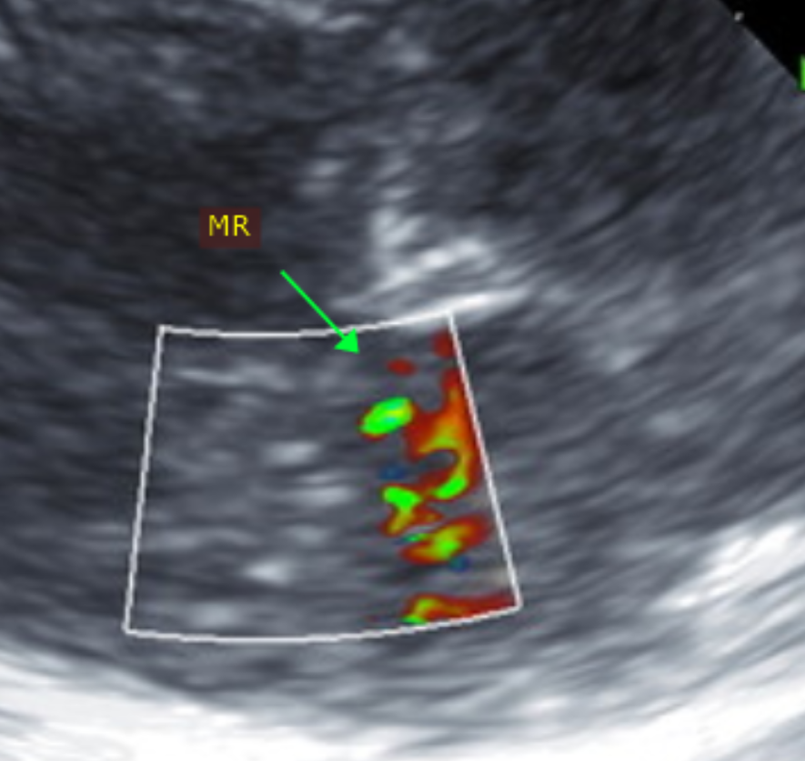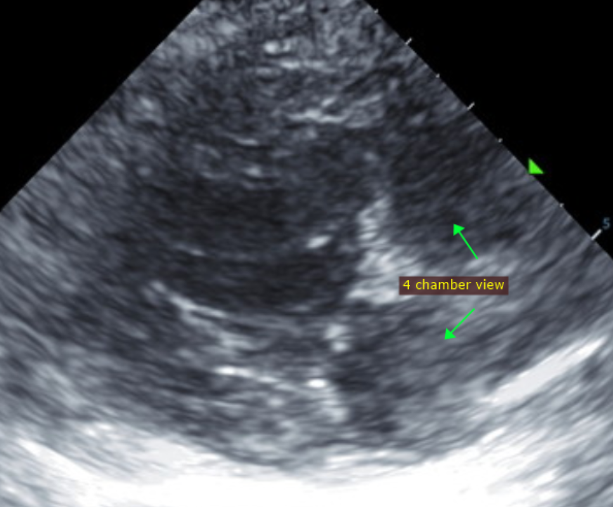

The information and recommendations provided are based on the images presented by the referring veterinarian. No evaluation can be communicated regarding pathology that was not visible in the image/video clips provided.

Thank you for this referral. This report was generated using transcription software, and minor dictation errors may be present. If the clinical or image interpretation does not parallel your findings or if I can be of any further assistance, please contact me.

Maggie Machen Lamy, DVM
Diplomate of the American College of Veterinary Internal Medicine (Cardiology)
info@sonopath.com

